

**ABBOTTABAD UNIVERSITY OF SCIENCE AND TECHNOLOGY ABBOTTABAD**

**NAME : Sayyed Zain Ul Abidin Shah**

**SUBMITTED TO: Sir Jamal**

**ROLL NO : 12387**

**SUBJECT : DSA**

**DATE OF SUBMISSION : 12 Nov. 23**

Q1: Implement a basic queue using an array in Python. Include methods for enqueue, dequeue, checking if the queue is empty, and finding the size of the queue.

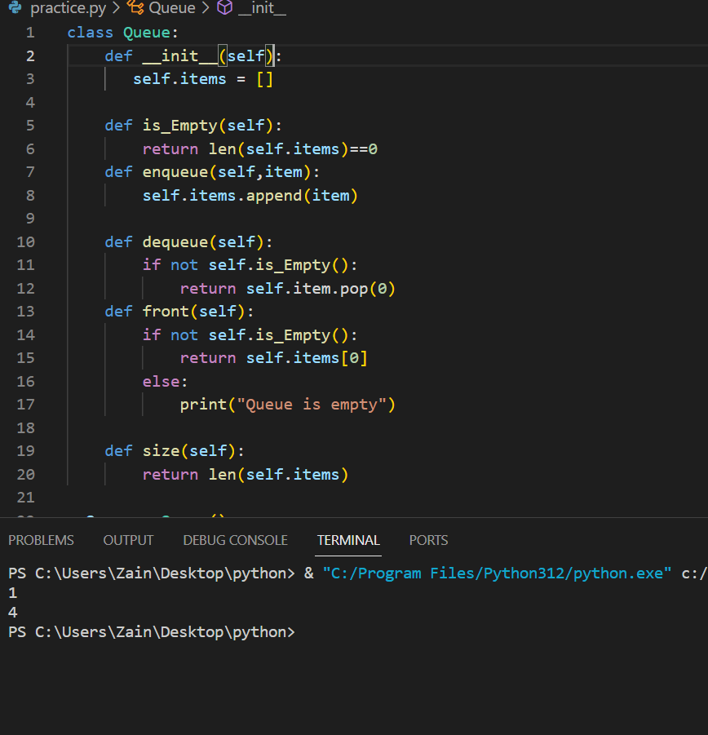

Q2: Implement a circular queue in Python. Include methods for enqueue, dequeue, checking if the queue is empty, checking if the queue is full, and finding the size of the queue.

